1)differences Between HTML and HTML5
1)HTML5 has audio and video support

2)Canvas,SVG and other graphic are supported
int HTML5

3)HTML5 more mobile friendly

4)Doctype declarations is simple

5)Allowing Drag and Drop effects

6)Allows JS to run in background.Possible due to Js Web Worker API in HTML5
7)New elements like nav,header,aside,article,main,<section>

2)What are new tags in media elements in HTML5?
<audio> - This tag is used to embed audio content into a web page.

<video> - This tag is used to embed video content into a web page.

<source> - This tag is used to specify the URL of the media file and its type.

<track> - This tag is used to provide timed text tracks for video and audio elements.
<audio> and <video> attributes - New attributes were introduced for <audio> and <video> tags to specify controls, autoplay, loop, and other features.

These new tags and attributes have made it easier to add and manipulate media elements in web pages without relying on third-party plugins or tools.

3)Drag and Drop?
Implementing drag and drop functionality in HTML5 is relatively simple. Here are the basic steps:

Add the draggable attribute to the element you want to make draggable. For example, if you want to make an image draggable, you can add the attribute to the <img> tag like this:

<img src="image.jpg" draggable="true">
Add event listeners for the dragstart and dragover events. The dragstart event fires when the user starts dragging an element, and the dragover event fires when the user is dragging an element over a drop target.

document.addEventListener("dragstart", function(event) {
// code to handle dragstart event
});

document.addEventListener("dragover", function(event) {
// code to handle dragover event
});
Specify the drop target by adding event listeners for the dragenter and drop events. The dragenter event fires when the user drags an element over a drop target, and the drop event fires when the user drops the element on the target.

document.addEventListener("dragenter", function(event) {
// code to handle dragenter event
});

document.addEventListener("drop", function(event) {
// code to handle drop event
});
In the event handlers, you can use the dataTransfer object to access the data being dragged and dropped. For example, you can use the setData() method to set the data to be transferred and the getData() method to retrieve it.

document.addEventListener("dragstart", function(event) {
event.dataTransfer.setData("text/plain", "Hello World!");
});

document.addEventListener("drop", function(event) {
var data = event.dataTransfer.getData("text/plain");
console.log(data); // outputs "Hello World!"
});
That's it! With these basic steps, you can implement drag and drop functionality in your web applications.

4)What are the new Form input elements in HTML5?
<input type="email">: This input element is used for email addresses and can validate that the entered text is in the correct email format.

<input type="url">: This input element is used for URLs and can validate that the entered text is in the correct URL format.

<input type="tel">: This input element is used for telephone numbers and can validate that the entered text is in the correct phone number format.

<input type="search">: This input element is used for search queries and can provide a search-specific keyboard on mobile devices.

<input type="color">: This input element is used for selecting colors and displays a color picker.

<input type="range">: This input element is used for selecting a value within a range, and can display a slider control.

<input type="date">, <input type="time">, and <input type="datetime-local">: These input elements are used for selecting dates, times, or both, depending on the type.

<input type="number">: This input element is used for entering numeric values and can display a numeric keypad on mobile devices.

<input type="file">: This input element is used for uploading files from the user's device.

5)Explain the concept of web storage of HTML5?
Web storage is a feature introduced in HTML5 that allows web applications to store data locally in a user's browser. There are two types of web storage: localStorage and sessionStorage.

localStorage allows developers to store data without an expiration date. This means that the data will persist even after the browser is closed and reopened. The stored data can be accessed by any page within the same domain.

sessionStorage, on the other hand, allows developers to store data for a single session. This means that the data will be available only while the browser is open and the session is active. Once the session ends or the browser is closed, the data is cleared.

Both localStorage and sessionStorage provide a simple key-value storage mechanism using the setItem(), getItem(), and removeItem() methods of the Storage object.

6)Explain Geolocation API in HTML5
The Geolocation API is a feature introduced in HTML5 that allows web applications to retrieve a user's geographical location information, such as latitude and longitude, directly from the browser. This information can be used to provide location-based services, such as finding nearby restaurants or displaying maps.

The Geolocation API works by accessing various sources of location information, such as GPS, Wi-Fi, and IP address. The browser prompts the user for permission to access their location, and once the user grants permission, the browser determines the location using the available sources.

The Geolocation API provides a simple API for developers to access the users location information, using the navigator.geolocation object. The getCurrentPosition() method is used to retrieve the user's current location, while the watchPosition() method is used to continuously monitor the user's location and provide updates

7)List page structure element of HTML5
HTML5 introduced several new structural elements that can be used to create well-organized and accessible web pages. Some of the main page structure elements in HTML5 are:

<header>: Used to define the header section of a web page.
<nav>: Used to define a block of navigation links.
<main>: Used to define the main content of a web page.
<article>: Used to define a self-contained article or piece of content on a web page.
<aside>: Used to define a block of content that is related to the main content but not necessarily part of it.
<section>: Used to define a section of a web page.
<footer>: Used to define the footer section of a web page.
<h1> to <h6>: Used to define headings on a web page.
<figure> and <figcaption>: Used to define a figure and its caption.

8)What is Application Cache in HTML5 and why is it used?
Application Cache, also known as AppCache, is a feature in HTML5 that allows web developers to create web applications that can be accessed offline. It allows users to continue using a web application even when they are not connected to the internet.

AppCache works by allowing developers to specify a list of files that should be cached locally by the user's browser. These files can include HTML, CSS, JavaScript, images, and other resources needed for the application to run. When a user accesses the web application while online, their browser will download and cache these files. When the user goes offline, their browser will use the cached files to continue running the application.

AppCache is used to improve the user experience of web applications by allowing them to be used offline. This is especially useful for mobile applications where internet connectivity may be spotty or slow. By using AppCache, developers can ensure that their application remains accessible and functional, regardless of the user's internet connection.

Advantages:
Offline Browsing
Speed

9)What is the difference between HTML elements and tags
An HTML tag is a piece of code that specifies a particular type of HTML element. Tags are used to define the structure and content of an HTML document. Tags are surrounded by angle brackets, such as <html>, <body>, and <p>. They usually come in pairs, with an opening tag and a closing tag that surround the content of the element, like this: <p>This is a paragraph.</p>

So, to summarize, a tag is the syntax used to define an HTML element, while an element refers to the entire content between the opening and closing tags, including the tags themselves and any content in between.

10) What are tags and attributes in HTML?
HTML attributes, on the other hand, provide additional information about HTML elements. They are added to the opening tag of an element and are used to modify the element's behavior or appearance. For example, the href attribute is used to specify the URL of a hyperlink, and the src attribute is used to specify the URL of an image. Here is an example of an anchor tag (<a>) with an href attribute:

HTML tags are used to define the structure and content of an HTML document. They are surrounded by angle brackets, such as <html>, <body>, and <p>. HTML tags usually come in pairs, with an opening tag and a closing tag that surround the content of the element. For example, a paragraph element can be defined using the <p> tag as follows

11) Inline and block elements in HTML5?
Inline elements are displayed within a line of text and do not start on a new line.
Examples of inline elements include <span>, <a>, <img>, <strong>, and <em>.
Inline elements can be nested inside block elements, but not other inline elements.

Width and Height: Inline elements adjust their width and height automatically to fit their content, so specifying these properties may have no effect.

Margin and Padding: Setting margin or padding on inline elements may not have the expected results because they won't create a block around the content. Instead, they will add space around the element, affecting the layout of other elements on the same line.

**Block elements**
Block elements start on a new line and take up the full width available.
Examples of block elements include <div>, <h1> to <h6>, <p>, <ul>, <ol>, and <li>.
Block elements can contain other block elements and/or inline elements.
Here's an example of the difference between inline and block elements:

difference between canvas and SVG?
50. Explain new input types provided by HTML5 for forms?
Explain the layout of HTML

12)what is box modal
box modal is essentially a box that wraps around every HTML element.
it consists of margin,border,padding,,content

The box model is a fundamental concept in CSS that describes how elements are
laid out on a web page. In the box model, every HTML element is considered a rectangular box that contains the content, padding, border, and margin.

The box model can be broken down into four parts:

Content: This is the actual content of the HTML element, such as text, images, or other HTML elements.

Padding: This is the space between the content and the border. It is typically used to create space around the content and improve readability.

Border: This is the line that surrounds the padding and content. It is used to define the boundary of the element and can be styled with different colors, widths, and styles.

Margin: This is the space outside the border. It is typically used to create space between elements and improve the overall layout of the page.

All of these parts together determine the total size of the HTML element. The width and height properties of an element refer to the total size, including content, padding, and border, but not margin.

It's important to understand the box model when creating layouts with CSS because the size and positioning of elements depend on it. For example, if you set the width of an element to 100px and add 10px of padding and a 2px border, the total width of the element will be 124px (100px + 10px + 10px + 2px + 2px). This can affect how the element interacts with other elements on the page and how it responds to different screen sizes and devices.

13) how position:static,relative,sticky,absolute works

# position:static||relative||fixed||absolute||sticky
# position:static #by default
# # static positioned elements are not affected by top,left,right,bottom
# # it always position in it's normal flow

# position:relative
# # positioned relative to its normal flow
# # Setting the top, right, bottom, and left properties of a relatively-positioned element will cause it to be adjusted away from its normal position. Other content will not be adjusted to fit into any gap left by the element.

# position:fixed
# #is positioned relative to viewport which means it always stays at same place even if page scrolled
# position:absolute
# # is positioned relatives to nearest positioned ancestor
# if no positioned elements it positioned,it uses document body
# position:sticky
# # positioned based on user scroll position
# z-index property tells stack order of element

14)What is box-sizing?
box-sizing is a CSS property that determines how the width and height of an HTML element are calculated. The box-sizing property has two possible values:
by default it is content-box

content-box: This is the default value. The width and height of an element are calculated based on the content inside the element, and any padding or border added to the element is added to the width and height.

border-box: The width and height of an element are calculated based on the content inside the element, and any padding or border added to the element is included in the width and height. This means that the padding and border do not increase the overall size of the element, and any specified width or height will include the padding and border

# The CSS box-sizing property allows us to include the padding and border in an element's total width and height.
# By default width calculated like this
# width + padding + border = actual width of an element
# height + padding + border = actual height of an element
# box-sizing: border-box;

15)what are the new features in CSS3
# box-shadow,animations,transitions,attribute selectors

# css3 attribute selectors:
# a[href^='Sri']
# a[href$='Sri']
# a[href*='Sri']

# pseudo classes:
# visited,hover,n-child,
# :not()

# CSS3 colors:
# previous hexadecimal and rgb()
# but now
# RGBA(r,g,b,alpha)
# alpha between 0-1

# Rounded Corners:
# border-radius:5px;
# Shadow:
# dropshadows,textshadow
# box-shadow:x y blur spread color,
# text-shadow:
# multiple background images:
# background-image:he
# url(firstImage.jpg),
# url(secondImage.gif),
# url(thirdImage.png);

16) what is difference between pseudo classes and pseudo elements:
Pseudo-classes: Select and style an element based on its state or interaction with the user, such as :hover, :active, :focus, :visited, :nth-child(), etc.

Pseudo-elements: Select and style a specific part of an element, such as ::before, ::after, ::first-letter, ::first-line, etc

17) What are the values of white-space?

# white-space:nowrap
# white-space:normal
# white-space:pre
# white-space:pre-wrap

18)what is difference between width:auto and width:100%
The width:auto property in CSS sets the width of an element to be determined automatically by the browser based on the content inside it. This means that the element will expand or shrink to fit its content.

On the other hand, the width:100% property sets the width of an element to be equal to its parent element's width. This means that the element will take up 100% of the available horizontal space within its parent container.

The key difference between these two properties is that width:auto adjusts the width based on the content inside the element, while width:100% adjusts the width based on the size of the parent element.

In general, if you want an element to adjust its width dynamically based on its content, you should use width:auto. If you want an element to take up the full width of its parent container, you should use width:100%.

19)What is the purpose of the z-index?
it helps to specify stack order of positioned elements that may overlap another
z-index default is 0 can take any positive or negative numbers
The element is positioned: z-index only works on positioned elements, that is, elements with a position property of absolute, fixed, relative, or sticky

20) How would you optimize the loading speed of a webpage using HTML and CSS techniques?
answer this
To optimize the loading speed of a webpage using HTML and CSS techniques, you can implement the following practices:

1. Minimize and compress your CSS and HTML: Remove unnecessary whitespace, comments, and code, and combine multiple CSS or JavaScript files into a single file. Minification reduces file size, leading to faster loading times. Additionally, consider using gzip compression to further reduce the file sizes.

2. Use asynchronous loading: Load CSS and JavaScript files asynchronously to prevent blocking the rendering of the page. Place JavaScript files at the end of the body or use the `async` or `defer` attributes to ensure they don't delay the rendering process.

3. Optimize images: Compress and optimize images to reduce their file size. Use appropriate image formats (e.g., JPEG for photos, PNG for graphics with transparency) and consider using responsive images with the `srcset` and `sizes` attributes to serve different sizes based on the device's capabilities.

4. Lazy loading: Implement lazy loading for images and videos. This technique loads content as the user scrolls, rather than all at once, improving initial page load time. There are libraries and plugins available to assist with lazy loading implementation.

5. Minimize HTTP requests: Reduce the number of HTTP requests by combining multiple CSS files into one and using CSS sprites for icons or small images. This reduces the round trips required to fetch resources, improving overall loading speed.

6. Use efficient selectors: Optimize CSS selectors to target elements more efficiently. Avoid using overly complex selectors that require extensive DOM traversal, as they can slow down rendering. Use classes and IDs whenever possible to improve performance.

7. Inline critical CSS: Inline the critical CSS directly into the HTML file or use techniques like server-side rendering to deliver the critical styles inline. This allows the browser to render the page faster, even before external stylesheets are loaded.

8. Utilize caching: Set appropriate cache headers to enable browser caching of static resources. This allows returning visitors to load the page faster by retrieving cached files instead of making new requests.

9. Implement a Content Delivery Network (CDN): Use a CDN to distribute your website's static assets across multiple servers geographically closer to your users. This reduces latency and improves loading speed.

10. Use CSS animations and transitions judiciously: Animations and transitions can enhance user experience, but excessive use can negatively impact performance. Be mindful of the number and complexity of animations on your page.

What is HTML and its uses?
HTML stands for HYPER TEXT MARKUP LANGUAGE, and is a markup language.
Hyper – stands for ANCHOR or HREF element
Example: <a href
Text – stands for the text in document.
MARKUP LANGUAGE – stands for the structure of document using elements like heading paragraph, link and more.
HTML is used to create User Interface components (collection of UI components).
HTML is a language used to create UI components, html will provide elements and each and every element provides some format called as tags with help of these creating UI components.
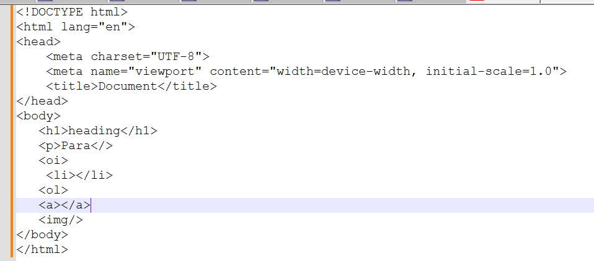
How does the HTML5 DOCTYPE declaration look and why is it simplified?
The HTML5 <!DOCTYPE html> declaration is simplified to just one line because HTML5 isn't based on SGML like previous versions. It’s designed to trigger standards mode in all modern browsers without the need for a complex DTD (Document Type Definition).
Element in HTML?
An HTML element is a component or building block of an HTML document, Elements will structure the HTML document.
An element is a part of a web page that is defined by a start tag, content, and an end tag. Elements can contain other elements, as well as text, images, videos, audio, and other types of content.
Tag in HTML?
Tag is a format of elements that structure the content on a web page. HTML tags are enclosed in angle brackets < >, and consist of two types: self-closing tag paired tag.
What are the new features introduced in HTML5?
Semantic elements: <nav>, <main>, <section>, <article>
Multimedia: <audio>, <video>
Graphics: <canvas>, <svg>
Form enhancements: <input type="date">, <input type="email">, placeholder, required
Local storage: localStorage, sessionStorage
Geolocation API
What is the difference between id and class?
id is unique; used once per page.
An id is unique and used to identify a single element on a page. It’s commonly used for scripting (JavaScript) or deep linking (#anchor)
class can be used multiple times; ideal for styling multiple elements.
A class is reusable and ideal for applying common styles to multiple elements.
In our UI project, we used class selectors for repeated components like cards, and ids for targeted JavaScript actions like modal triggers or scroll navigation.
What happens if you apply the same id to two elements?
It breaks the uniqueness rule. JavaScript’s getElementById() returns only the first match, and CSS behavior becomes unpredictable.
Explain the concept of semantic HTML? Why is it important?
Semantic HTML uses meaningful tags which clearly describe the content's role.
It improves accessibility and Search Engine Optimization, and helps developers understand structure better than using generic <div>
Semantic HTML elements like <article>, <main>, <nav>, <aside>, <header>, <footer>, and <section> give meaning to the content, rather than just structure.
<article> – self-contained content
<aside> – Sidebars, ads, notes
<nav> – navigation links
<main> – main document content
<header> – describes the page
<footer> – copy right details
<section> - Groups related content
What is the difference between <section>, <article>, <aside>, and <div>?
I use semantic tags like <section>, <article>, and <aside> to give structure and meaning to content, they help search engines and assistive technologies better understand the content which improves accessibility.
I use <div> only when I need a generic container for styling or layout, and there’s no semantic meaning.
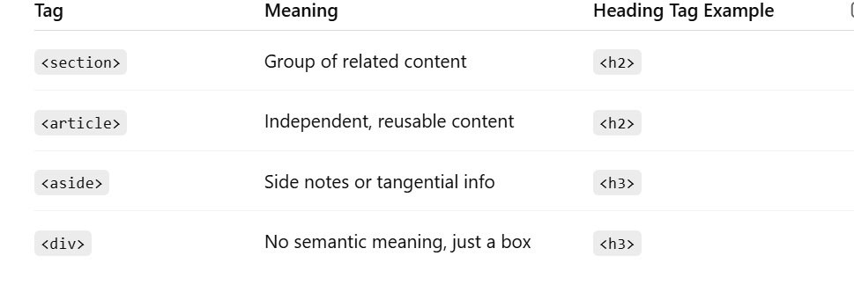
What is the difference between <section> and <article>?
<section> is used to group related content together under a common theme or heading. It helps organize the page into logical blocks.
<article> is used for self-contained, reusable content that can stand alone — like a blog post, news article, forum post, or user comment. It makes sense even outside the context of the page.
Where should <nav> be placed?
Typically inside <header> or directly under it. It represents a group of navigation links used for site navigation.
What does display: flex do on the <body> tag?
It makes the body a flex container, allowing us to canter the form both horizontally and vertically using justify-content and align-items.
Why use flex-direction: column in the <form>?
By default, Flexbox arranges items in a row. We set flex-direction: column to stack the form fields vertically.
What are the key features introduced in HTML5 forms?
HTML5 introduced new input types (email, url, date, number, etc.), form validation attributes (required, min, max, pattern), and improved accessibility with label, placeholder, and autocomplete.
Input Type | Purpose
text | Single-line input
email | Validates email format
number | Numeric input
date | Date picker
password | Masked input
checkbox | Multiple selections
radio | One selection from options
submit | Form submit button
What are data- attributes? How and when should you use them?
Data attributes are custom HTML attributes starting with data- that let you store extra metadata on elements. They’re useful for small, element-specific values like IDs, configs, or states, which JavaScript can read via element.dataset. They’re not for large or sensitive data, just for lightweight info tied directly to the DOM.”
How do inline, block, and inline-block elements differ in HTML/CSS?
block elements take full width and start on a new line — useful for layouts.
inline elements flow with text but can't be resized.
inline-block gives the best of both — you can align inline and also control size.
I often use inline-block for buttons or cards inside flexible containers.
What is the Box Model in CSS? How does padding, margin, border, and content interact?
The Box Model in CSS describes how every HTML element is treated as a rectangular box that wraps around its content. It consists of:
Content: The actual text or image inside the element.
Padding: Space between the content and the border — it creates breathing room inside the element.
Border: The edge or outline of the element.
Margin: Space outside the border — it separates the element from others on the page.
|<-- margin -->|<-- border -->|<-- padding -->| content |
we used box-sizing: border-box to avoid layout shift issues. That way, padding and border stay within the defined width.
How does HTML5 handle offline storage? Compare localStorage vs sessionStorage vs cookies.
HTML5 introduced localStorage and sessionStorage as more efficient, client-side storage options compared to cookies. While localStorage stores data persistently, sessionStorage is limited to a tab session. Unlike cookies, neither are sent to the server automatically, reducing network load.
What is CSS and its uses?
CSS stands for Cascading Style Sheets, and it is a language used for styling and formatting HTML elements or UI components how it should display on web page.
Using CSS properties HTML elements will be styled up.
What does display: flex do on the <body> tag?
It makes the body a flex container, allowing us to center the form both horizontally and vertically using justify-content and align-items.
Why use flex-direction: column in the <form>?
By default, Flexbox arranges items in a row. We set flex-direction: column to stack the form fields vertically.
Align Radio Buttons and Checkboxes side by side using Flexbox?
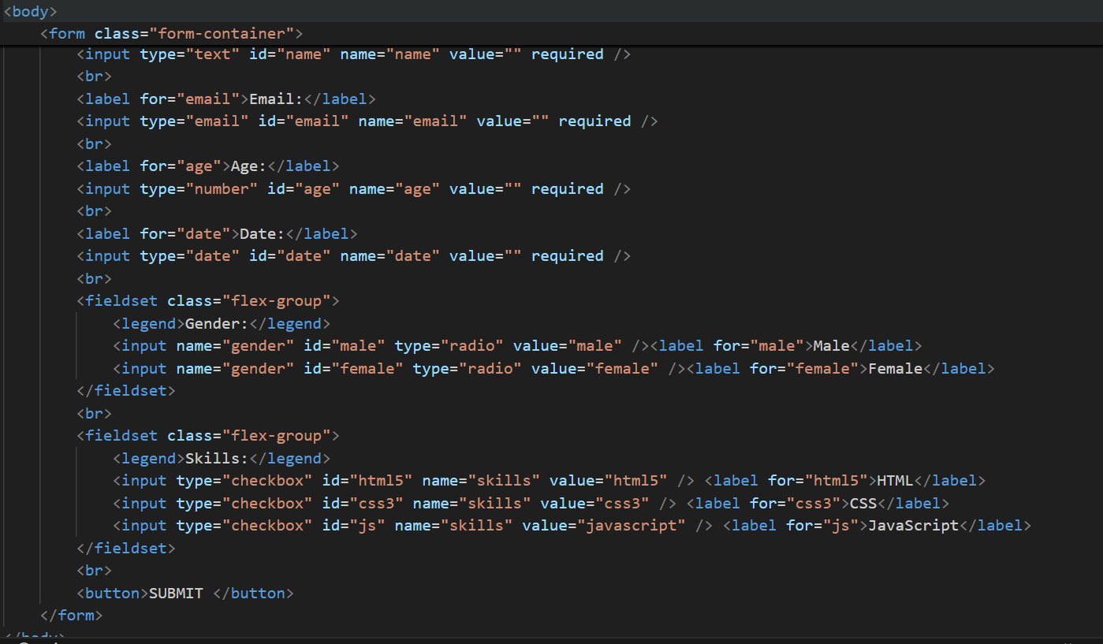
Why use Flexbox and Grid in CSS3?
Feature | Flexbox | Grid
Layout Type | One-dimensional (row OR column) | Two-dimensional (rows AND columns)
Best For | Aligning items in a row/column | Complex layouts with rows + columns
Alignment | Easy vertical & horizontal | Supports alignment too
Responsiveness | Very flexible with media queries | Great with auto-fit/auto-fill
Browser Support | Excellent | Excellent (modern browsers)

Why should we use Flexbox or Grid over floats or inline-block?
Flexbox and Grid simplify modern UI layout challenges. Flexbox excels at aligning items along one axis, while Grid is perfect for two-dimensional layouts. They improve responsiveness, readability, and reduce the need for complex CSS hacks.
When should you use Grid over Flexbox?
Use Grid when you need to control both rows and columns — like page layouts, dashboards, or image galleries. Flexbox is better for linear (row or column) alignments.
What’s the difference between relative, absolute, and fixed positioning in CSS?
relative shifts an element slightly from where it naturally appears.
absolute is positioned with respect to the nearest positioned ancestor. It’s useful for dropdowns or badges.
fixed is stuck to the viewport — perfect for sticky navigation or floating CTAs.
In our UI, I used absolute for tooltips inside cards and fixed for sticky filter panels on scroll.
Difference between em, rem, %, px in CSS?
I use rem for consistent scalable typography across the app, em for element-relative spacing, % for fluid layouts, and px only when precise control is needed.
In my Nokia project, we switched from px to rem for accessibility and responsiveness — especially for large-screen dashboards.

